Inexx Web Design

Remindify

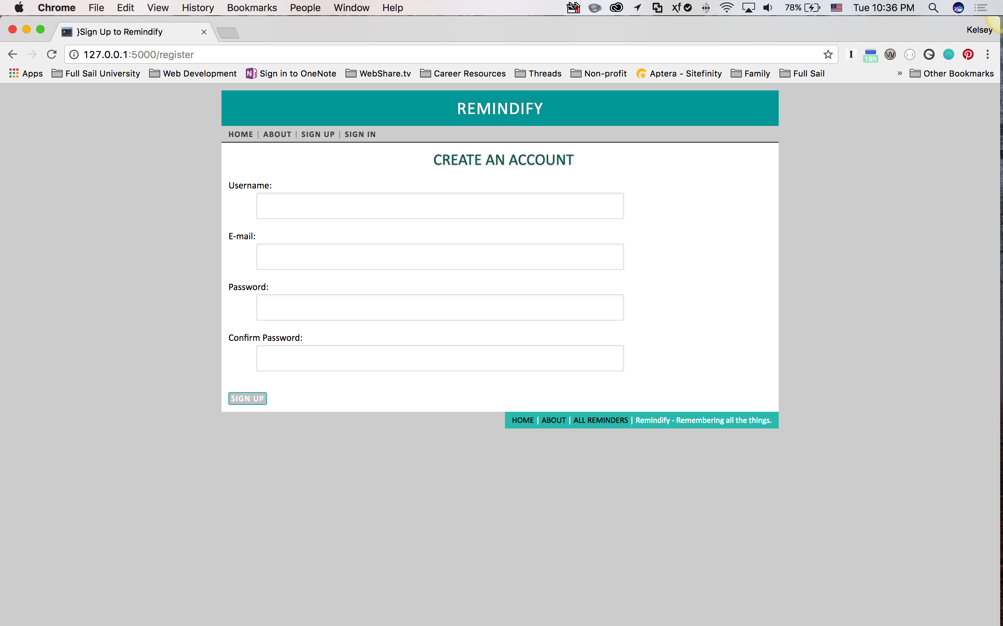

# Remindify – App Summary

Remindify is a simple web application that allows users to create a login and store their reminders in a list format. I chose this application because I make many lists and often lose the slips of paper I put them on. Remindify is different in that it has a simple UI and doesn’t ask users to accept irritating notifications or emails. The user session stores all data into the database and is lightweight and easy. With simple yet relevant features such as a CRUD login with a third party Gravitar API, and eventually the ability to share reminders with those who need to know about it.

## What is Flask?

A python based micro framework to put it *very* simply. *But, wait…what is a micro framework?* Flask is considered a micro framework because it doesn’t require any libraries or tools, has no database abstraction layer, no form validation, or any components with third-party libraries providing common functions. With that being said, Flask does support extensions that can provide application features when implemented in Flask itself. These extensions are very frequently updated. Last but certainly not least, Flask supports secure cookies (client side sessions) which is fantastic because that is exactly what I need to create this app.

# Schedule

Sed eleifend interdum pede. Mauris tincidunt, augue in egestas rutrum, arcu quam vestibulum diam, a condimentum magna pede mollis neque. Ut dictum leo eu purus. Quisque ante magna, volutpat non, tincidunt ac, gravida nec, pede.

|  |  |  |
| --- | --- | --- |
| Week 1 | Dolor Sit Amet | Version |
| Week 1 | Mapping out dev plan. | v.0.0 |
|  | Mapping basic structure. | v.0.0 |
| Week 2 | Gravitar Login | v.0.1 |
|  | Create a reminder | v.0.1 |
| Week 3 | Edit Reminders | v.0.2 |
|  | Stored Reminders | v.0.2 |
| Week 4 | Delete Reminders | v.0.3 |
|  | Share Your Reminder | v.0.3 |
|  |  |  |
|  |  |  |

|  |  |
| --- | --- |
| **Progress Schedule Week 1** |  |
| **Monday** | **Conduct framework research** |
|  | **Compare and contrast frameworks** |
| **Tuesday** | **Choose a framework** |
|  | **Find significant tutorials for framework** |
| **Wednesday** | **Learn to create a base structure** |
|  | **Brainstorm app ideas** |
| **Thursday** | **Map out app and features’ details** |
|  | **Develop dev plan** |
| **Friday** | **Create PRD based on dev plan** |
|  | **Turn in PRD and post Framework Selection** |
|  |  |

|  |  |
| --- | --- |
| **Progress Schedule Week 2** |  |
| **Monday** | **Begin Tutorials** |
|  | **Begin creating basic structure of the app** |
| **Tuesday** | **Test HelloWorld app** |
|  | **Begin dev on login feature** |
| **Wednesday** | **Test login feature, debug if needed** |
|  | **Optimize login** |
| **Thursday** | **Begin dev on Create Reminder** |
|  | **Continue dev** |
| **Friday** | **Test login and create reminder together** |
|  | **Debug if needed, turn in NLT Sunday** |
|  |  |

|  |  |
| --- | --- |
| **Progress Schedule Week 3** |  |
| **Monday** | **Begin creating the RU of CRUD** |
|  | **Create update feature of the Reminders** |
| **Tuesday** | **Test update feature with login and create** |
|  | **Debug and refactor as needed** |
| **Wednesday** | **Create stored reminders feature** |
|  | **Create stored reminders feature** |
| **Thursday** | **Test stored reminders feature note bugs** |
|  | **Debug and refactor if needed** |
| **Friday** | **Review changes with pull request in features** |
|  | **Pull into master if all is well** |
|  |  |

|  |  |
| --- | --- |
| **Progress Schedule Week 4** |  |
| **Monday** | **Begin creating Delete feature** |
|  | **Continue dev on Delete feature** |
| **Tuesday** | **Test delete feature with login, create, and update** |
|  | **Debug and refactor as needed** |
| **Wednesday** | **Create share reminders feature** |
|  | **Create share reminders feature** |
| **Thursday** | **Test share reminders feature note bugs** |
|  | **Debug and refactor if needed** |
| **Friday** | **Make final adjustments to app** |
|  | **Pull into master if all is well** |
|  |  |